# [**Salary**](https://www.ambitionbox.com/profile/game-developer-intern-salary)

* **₹ 15,000/month**

# Infrastructure Cost

| Cost | Value | Units | Total |
| --- | --- | --- | --- |
| **Unity 3D Plus (Hosting and analytics)** | $399/year per seat (Rs.32,500*) | 2 | **₹66,046** |
| **Unity Teams Cloud storage** | Free usage and then  5-25GB, $5 per month  25+ GB, $5 per 25 GB (820) | 50GB | **Rs.11578.00** |
| **Collaboration** | Up to 3 free then 4+ users,  $7/user per month | 3 users | **Rs.24369.00** |

1. **Licenses for tools**

* [Unity Plus](https://store.unity.com/compare-plans) = $399/year x 2 = $798 = ₹***66,046***
* 

1. **Licenses for cloud tools**

* [Unity Cloud Storage](https://unity.com/products/unity-devops/pricing) for 50GB = $10/month = ₹***827/month***

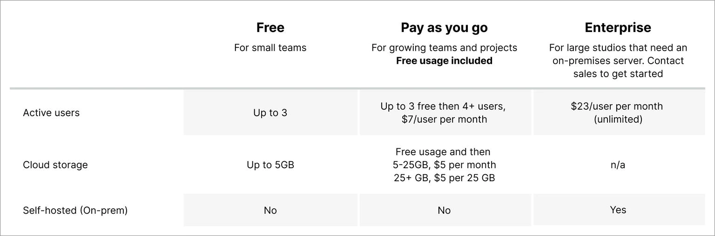

1. **Unity Teams**

* Unity Teams for collaboration $21/month = ₹***1,740/month***

1. **Hardware**

* [Requirements for Laptops](https://itsc.ontariotechu.ca/tele/business-and-it/fbit-specs_game-development.php) x 6
* [Example Laptop](https://www.flipkart.com/asus-tuf-gaming-a15-90whr-battery-ryzen-7-octa-core-5800h-16-gb-512-gb-ssd-windows-11-home-6-graphics-nvidia-geforce-rtx-3060-fa506qm-hn008w-laptop/p/itmcc4c1c0d500ac?pid=COMGGYY3RQKKKVKS&lid=LSTCOMGGYY3RQKKKVKSNV6PMX&marketplace=FLIPKART&q=gaming+laptop&store=6bo%2Fb5g&srno=s_1_5&otracker=AS_QueryStore_HistoryAutoSuggest_8_0_na_na_na&otracker1=AS_QueryStore_HistoryAutoSuggest_8_0_na_na_na&fm=search-autosuggest&iid=5e4a0c93-5af3-44dd-a3f0-eb77ce80f45b.COMGGYY3RQKKKVKS.SEARCH&ppt=sp&ppn=sp&ssid=zr44ii3wi80000001675966860568&qH=da5ee6f53d84b3c2) = ASUS TUF Gaming A15 with 90Whr Battery Ryzen 7 Octa Core 5800H

**Basic Costs:**

Salary - ₹17,500 x 6 = ₹1,05,000/month

Laptops - 6 units

Unity Pro - $399/year =  **₹**33,000

Unity Assets = on the go

Unity Collaboration and Cloud build = [Unity Cloud Storage](https://unity.com/products/unity-devops/pricing) for 50GB = $10/month = ₹***827/month***

Research interns salary is between ₹ 16,678 - ₹ 18,391/month

Being realistic we expect a salary of 15,000/month

Students so we can give 4hours/day

We have broken the costs to weekly, daily, hourly basis

Development time will be 13 months

**So cost** = 15,000 x 6 = 90,000/month

**Total** = 90,000 x 13 = 11,70,000